TITLE OF THE INNOVATION:
Adaptive Graph X (AGX): A Self-Optimizing Intelligent Graph Framework for Dynamic Data Processing and Traversal
PREAMBLE OF THE DESCRIPTION:
This architectural design and operational framework of Adaptive Graph X (AGX), is a next-generation
intelligent graph system. It serves as comprehensive reference for researchers, developers, and
system architects to understand the integration of adaptive intelligence, graph theory, and system
optimization techniques. AGX is designed to dynamically evolve the structure, traversal strategies,
and memory usage based on real-time data interactions.
DESCRIPTION:
Adaptive Graph X is a dynamic graph system which learns and adapts in real time and optimizing
path selection. This is done by using self-learning and predictive evaluation for smarter and efficient
decision-making.
FIELD OF INNOVATION:
Advanced Data Structures, Graph Theory, Artificial Intelligence, High Performance Computing,
Intelligent Systems Design. The AGX has an adaptive graph based architecture and it can optimize
itself by learning, evaluating dynamically and making predictions about decisions.
REASON FOR THE INNOVATION:
Traditional graph systems have some limitations no flex. Static structure, Limitations of Current Techniques Dynamic dataset traversal inefficiency High memory consumption for large scale graphs . Absence of optimal path choice Unable to optimize based on usage patterns To overcome these limitations, AGX introduces Decision Making with Adaptive Intelligence, Dynamic path optimization Memory-efficient graph storage Self-learning Structural evolution in real-time

OBJECTIVE:
Smart Pathfinding Adaptive Graph Topology Optimal Memory Usage Dynamic Path Optimization
Online Learning and Adaptation Handling Large Graphs Computational Efficiency Fast Data Analysis.
NOVELTY:
Graph Theory and integration of Adaptive Intelligence Predictive Path Selection Mechanism Dynamic
Evaluation of Traversal Strategies Hybrid Graph Storage Structures Auto-Switching Between
Traversal Methods (BFS/DFS) Memory Optimization with Active Node Focus Self-Learning Graph
System Real-Time Structural Adaptation.

BRIEF EXPLANATION OF THE INNOVATION:
The system comprises the following major components Adaptive Intelligence Layer Traversal Optimizer Memory Optimizer Adaptive Engine Hybrid Graph Representation System Graph Structure Module (Vertices and Edges)Dynamic Evaluation Module, Predictive Path Selector, Self-Learning Mechanism, BFS/DFS Execution Modules Application Interface Layer Node Tracking System Storage Compression Module Duplicate Removal System Auto Switching Controller Sparse Graph Optimization Unit
WORKING:
Adaptive Graph X (AGX) is an intelligent graph system that can keep evolving with runtime
interactions. Data is initially modelled in a generic graph form of vertices and edges, with support for
directed/undirected, weighted/unweighted variants. The system behaviour is monitored by the Adaptive Intelligence layer, which is used to select the best traversal paths through predictive path selection. It dynamically evaluates graph conditions and updates traversal strategies in real time.
The Traversal Optimizer selects BFS or DFS according to the graph structure and the query
requirements. It also keeps a record of visited nodes, so as not to do the same thing twice.
Simultaneously, the Memory Optimizer compresses the graph data, removes duplicate information
and focuses only on the active nodes, guaranteeing an efficient storage and decreasing the
unnecessary memory usage.

WORKING OF ALGORITHM:
Predictive Path Selection Algorithm:
Analyses the pattern of a graph and predicts the most efficient route to traverse before execution.
Dynamic Evaluation Algorithm:
Dynamically adapt the strategies and constantly monitor the traversal performance.
Traversal algorithms optimized.
Use BFS or DFS , depending on the graph properties and the type of queries .
Memory optimization algorithm :
Compress data, purge duplicates and keep active nodes to save storage.
Adaptive Switching Algorithm:
:
Run-time change of graph representations and traversal techniques. Algorithm taught to one self:
Use historical data to better inform future decisions and system efficiency.

USE:
Map Routing Systems, Recommendation Engines, Social Network Analysis, AI Pathfinding Systems ,.Network Optimization, Real Time Decision Systems

AGX with Intent-Based Computing System
1.What is Intent Based Computing System?
An Intent-Based Computing System is an intelligent system that understands the user’s intent, not just direct commands. It is focused on what the user wants to accomplish, not how to accomplish it. The system automatically decides and acts according to user behaviour, preferences and patterns.
2. How it Works in AGX
AGX’S Intent-Based Computing System that keeps track of user activities like app usage, time patterns and preferences. For instance, if a user always plays music when opening a game, AGX learns this activity. The next time the user opens the game, AGX will automatically launch the music without any input from the user. Pattern recognition, data analysis and decision making algorithms are used to do this.
3. AGX Characteristics
Automatic action upon user intent Learning user actions over time. Smart decision-making Reduced manual labour Customized experience
4. Advantages of Intent-Based System
Saves time by automating tasks Improves user experience Reduces complexity Provides intelligent responses Adapts to user actions dynamically
TIME & SPACE COMPLEXITY FOR AGX:

Operation | Time Complexity | Space Complexity
Add Edge | O(1) | O(1)
Display Graph | O(V + E) | O(1)
Dynamic Update | O(E) | O(1)
Adaptive Learning | O(E) | O(1)
Path Prediction | O((V + E) log V) | O(V)
Usage Tracking | O(V) | O(1)

WORKFLOW OF THE PROPOSED SYSTEM:
Fig 1: Architectural Diagram of Adaptive Graph X (AGX)

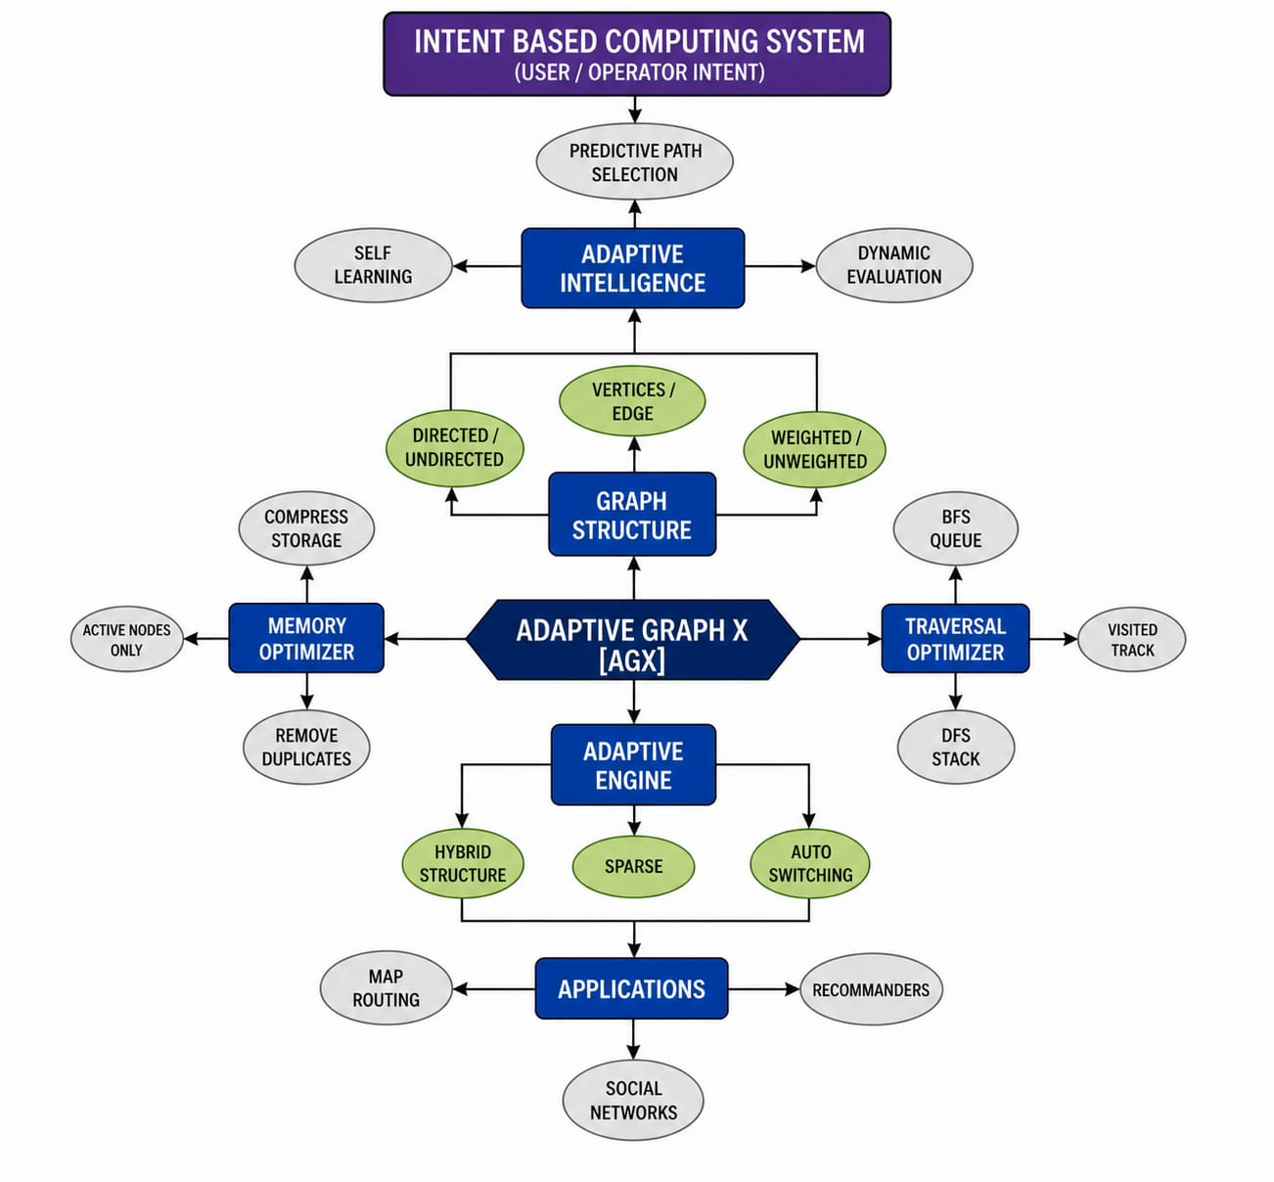

Fig 2: Flow of Graph Processing:
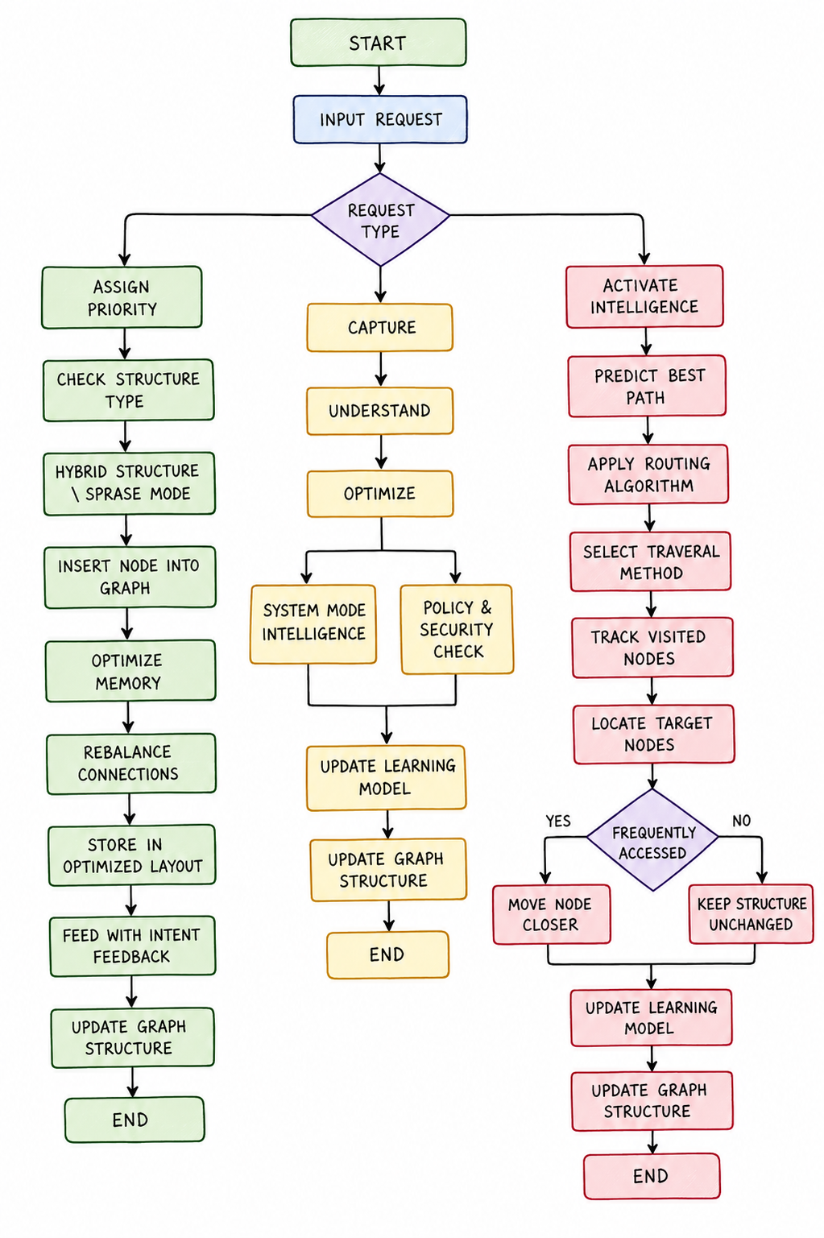

SUMMARY:
AGX Adaptive Graph X is a major advancement in the design of graph-based systems, blending
adaptive intelligence with traditional graph structures. AGX differs from traditional approaches
because its structure, traversal strategies and memory consumption are all dynamically optimized.
Its ability of learning from previous operations, predicting optimum routes and adapting to dynamic
conditions makes it very suitable to contemporary large-scale and data-intensive applications.
AGX brings efficiency, scalability and intelligence to create a new paradigm in graph processing
systems and intelligent data structures.

